|  |  |  |
| --- | --- | --- |
| **LAB 321 Assignment** | **Type:** | **Long Assignment** |
| **Code:** | **J3.L.P0048** |
| **LOC:** | **100** |
| **Slot(s):** | **5** |

**Title:** Product browse

**Background**

**Program Specifications**

Program a web site to brows product list

**Features:**

This website contains following main functions

* Function 1: Product list
  + Display list of root category
  + Display list of all products
  + When user click to category
    - List all sub categories belong to selected category
    - List all products belong to selected category

***Database description***

**Category table**

* Category ID
* Category Name
* Parent ID

**Product table**

* Product ID
* Product Name
* Category ID

Root category have Parent ID = 0

Sub category have parent ID is ID of an existed category

***Expectation of User interface:***

Pic1: Root category

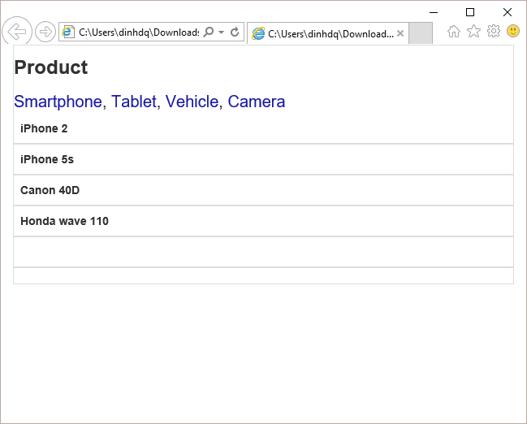

PIC 2 : Smartphone category

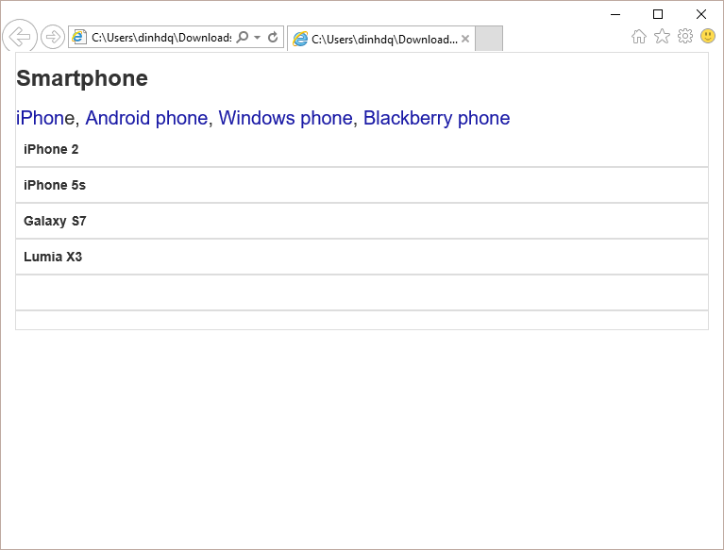

**Guidelines**

* Step 1 : Create web layout
* Step 2 : Create prototype
* Step 3 : Design database base on created prototype
* Step 4 : Code & Test